#
# There was no special.
# Move it and that’s it.
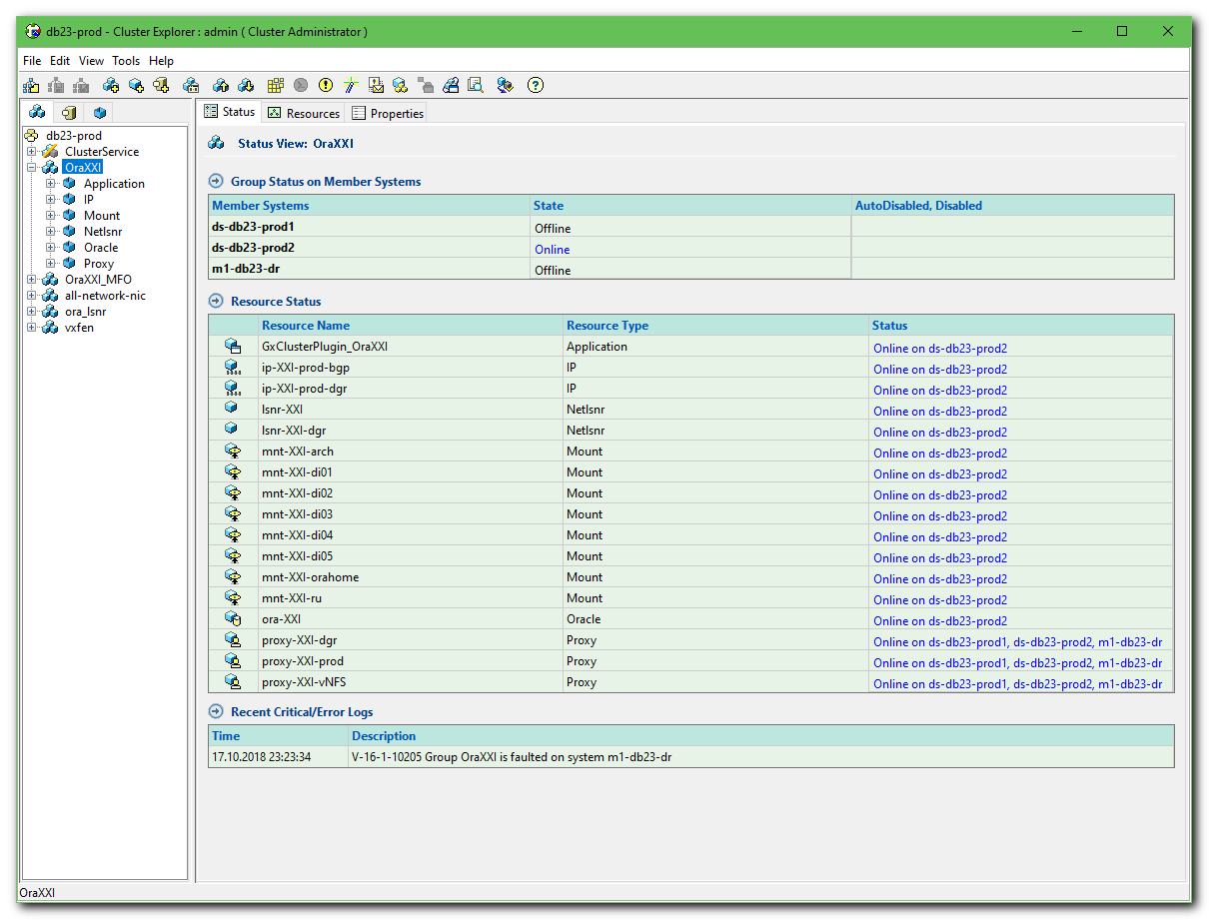

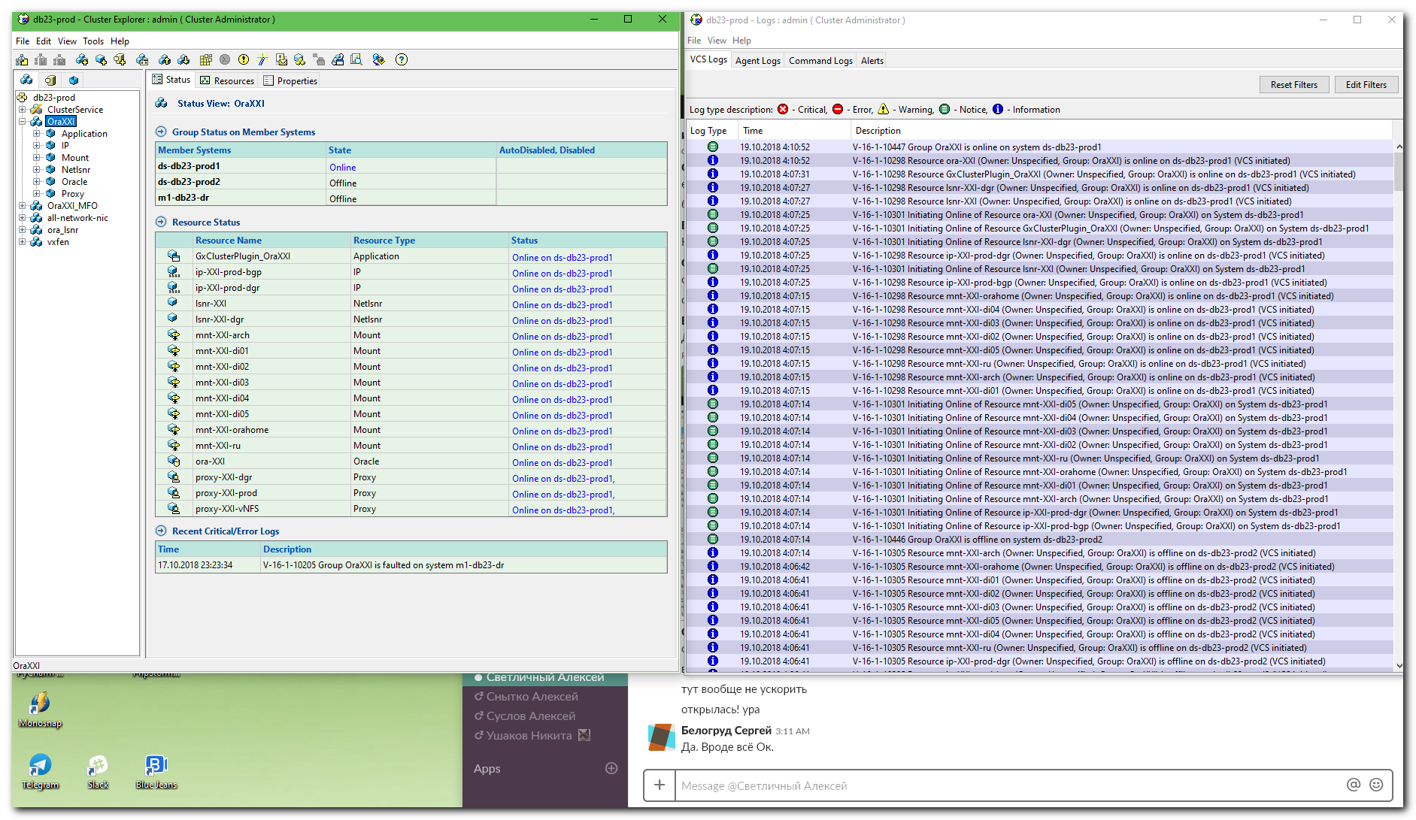
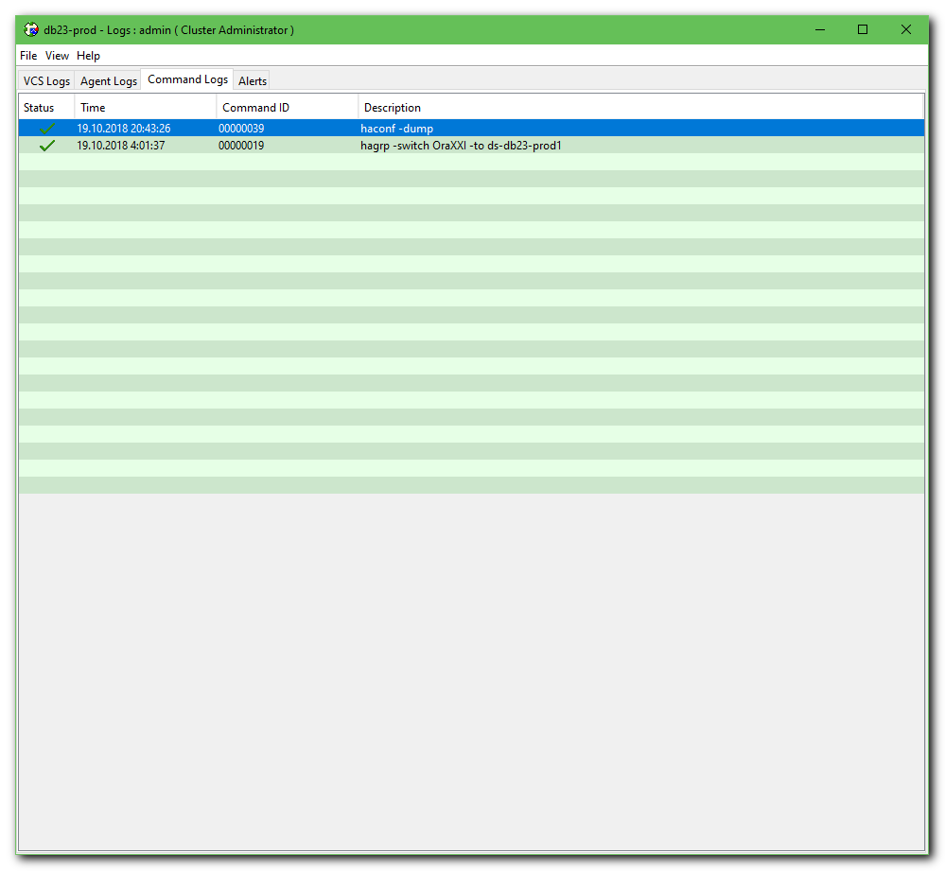

#
# 20181114
# Another one solution how to move database from one server to another.
# This way is used command line utilty.

# To be sure what is going on - needs to look at log file.
[18:31:15 root@ds-db26-prod1 ~]# tail -f /var/VRTSvcs/log/engine_A.log

[18:39:09 root@ds-db26-prod1 ~]# hagrp --help 2>&1 | less
...
hagrp -switch <group> -to <system>
...

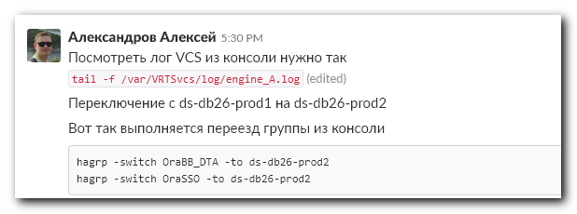

Александров Алексей [5:30 PM]
Посмотреть лог VCS из консоли нужно так
`tail -f /var/VRTSvcs/log/engine_A.log` (edited)

Переключение с ds-db26-prod1 на ds-db26-prod2
Вот так выполняется переезд группы из консоли
```hagrp -switch OraBB_DTA -to ds-db26-prod2
hagrp -switch OraSSO -to ds-db26-prod2```

hagrp -switch OraBB_DTA -to ds-db26-prod2
hagrp -switch OraSSO -to ds-db26-prod2

[19:33:12 root@ds-db33-prod1 ~]# hastatus -sum | grep -e "WFM"
B OraWFM ds-db33-prod1 Y N OFFLINE
B OraWFM ds-db33-prod2 Y N ONLINE
B OraWFM m1-db33-dr Y N OFFLINE
[19:34:55 root@ds-db33-prod1 ~]#

